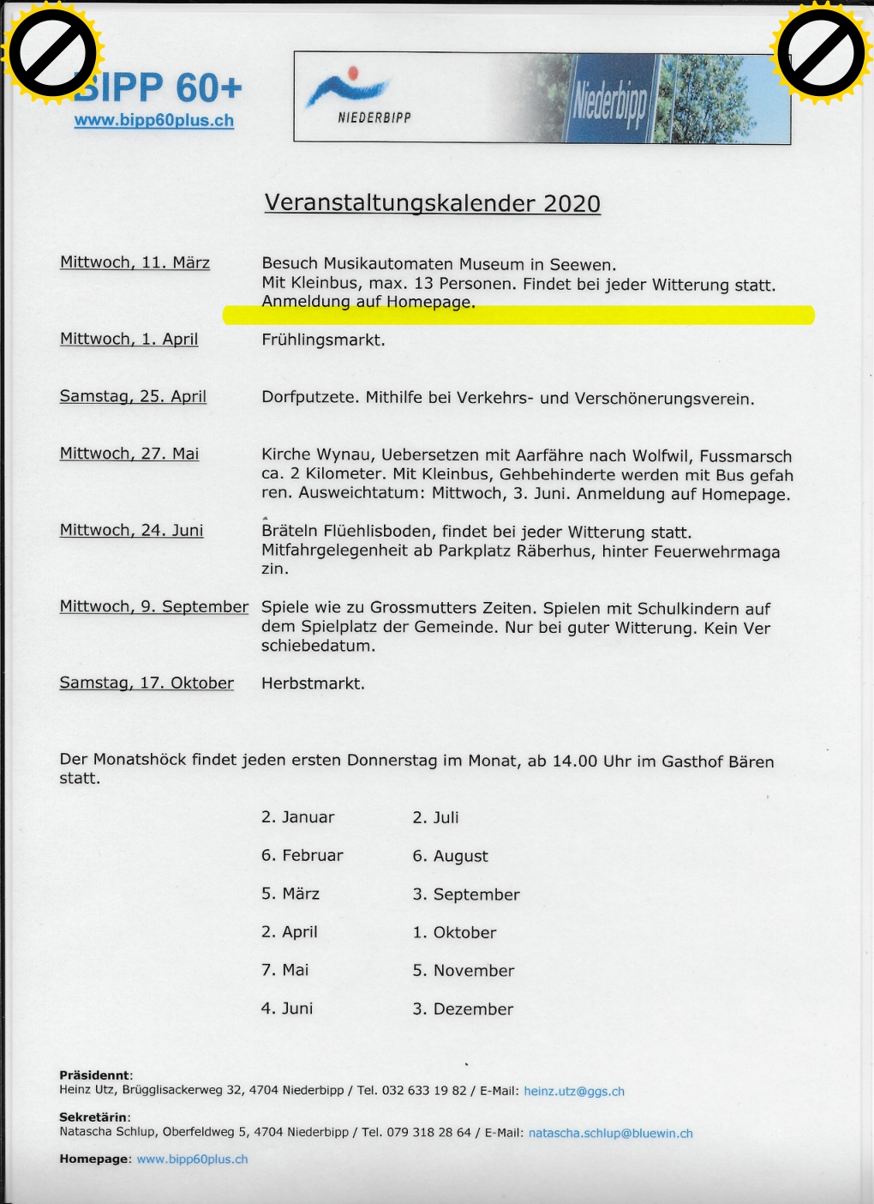

BIPP60Plus www.bipp60plus.ch 

www.bipp60plus.ch

[**P**](https://www.tracker-software.com/product/pdf-xchange-editor)

[**PD**](https://www.tracker-software.com/product/pdf-xchange-editor)